Waste and Consumption Eco-Action Plan
Consumption and Waste
Action | Class to do it | How to Monitor | Link to Curriculum | Community involvement
Trash Free Tuesday | Both  Sept.2013  free | Weigh the trash | Graphing, math  Need to re-advertise this | School wide
Cloth Napkins and dish towels | Both  March 2014  $50 | Count how many paper napkins saved. (400 per month) | Art, sorting and folding. | Make napkins for all. Ask for donations?  Bought at the thrift store
e-waste drive | PTA  Dec. 2013  Free | Sally will count it | Parent event | School Wide
Composting model | Both  March 2014  Cost of worms | Survey of understanding of composting | Science experiment | Have expert come? Parents collect bottles.
Green PTA meetings, plates, printed materials, etc. | Kinder. could make announcement  Sept. 2014  Cost of plates | Agenda not printed, plates not used | Social Studies- Making an announcement and teaching parents how. | Schoolwide

1-Eco Action Plan- Trash Free Tuesdays
The basic plan was to have a Trash Free Tuesday to encourage families to bring less landfill type trash. Everyone in the school and all families were notified by email and with a poster. No environmental problems were anticipated. See the poster on our Weebly site http://greencyc.weebly.com/2013-2014.html.
Monitor and Evaluate
A base-line of trash was collected prior to the initiative and the Kindergarten weighed the trash the next consecutive 6 Tuesdays. Afterwards they made a graph. The progress was displayed in the form of a graph for the school to see.
Link to the Curriculum
All classroom teachers start the year out by teaching their class about the three bins in the classroom and where each of their lunch trash items need to go, compost, recycle or landfill. This is a natural sorting activity as well. By weighing and graphing the results of Tuesday trash math was also incorporated into the curriculum. Please see the video on our Green Pages page. http://www.education.umd.edu/CYC/GreenPages/index.html
Involve the Community- Naeyc put an article in their March publication TYC about our Trash free Tuesdays.
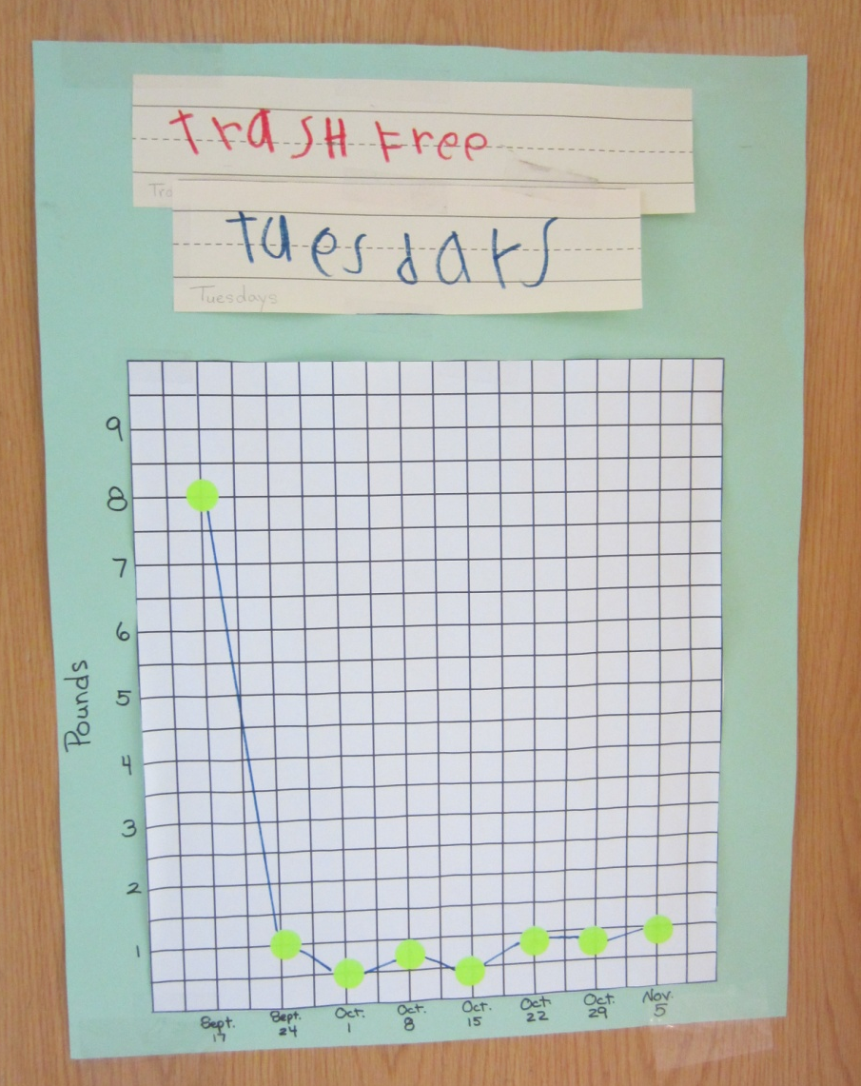

2- Cloth Napkins and Dish Towels- February 25, 2014- Cloth Napkins were purchased from the thrift store for each classroom to use on Trash Free Tuesdays. The savings amounts to approximately 100 napkins per week or 4,000 per year!
Curriculum- Children are responsible for folding, sorting and delivering the napkins once they are laundered. This is a natural sorting activity which is part of the math curriculum for preschoolers and kindergarteners.
Community Involvement- Parents are encouraged to think about purchasing lunch items with less packaging as children remind them.
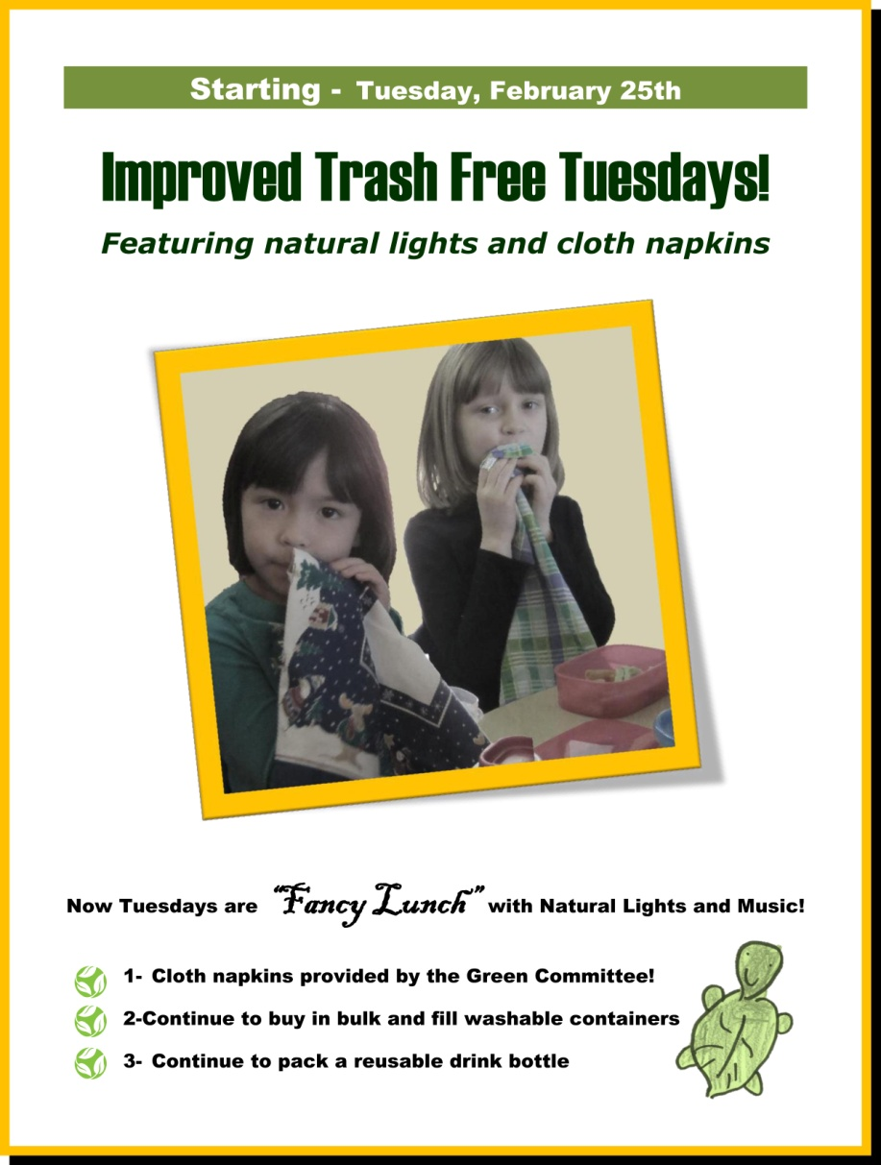
3- E-Waste Drive
Sally DeLeon, a parent Green Committee member, organized an e-waste drive for the school. She collected several boxes of old printers, computers and wires. This action was also used for the CYC’s Campus Wide Green Office initiative.
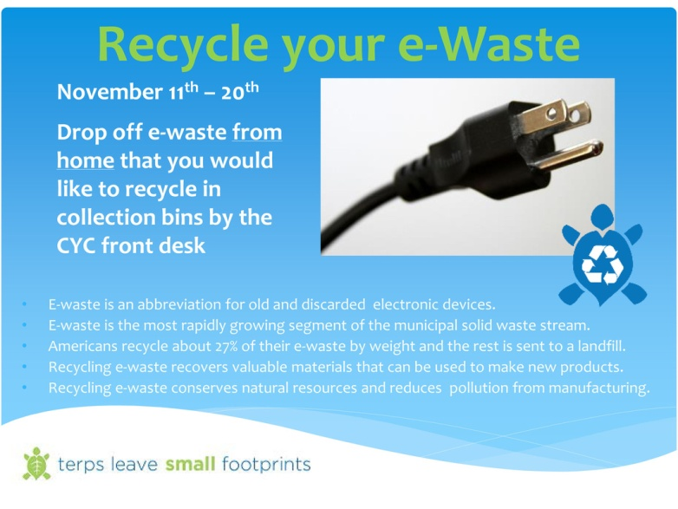
4- Composting Model- Julia Aquino implemented a lesson plan to teach children what happens to the compostable items they collect. First she surveyed the children to see if they knew what compost was. Although the children knew which items (paper towels and food scraps) went into the compost bin they did not understand what happened next. Using 2 liter bottles Ms. Aquino made a compost model with the children that produced soil over a period of a few weeks.

