School Grounds Eco-Action Plans
School Grounds

Action | Class | How to Monitor | Link to Curriculum | Community involvement
Rain Barrel | Both  June 2013  $100 | Estimate how many gallons saved (25 gal. weekly) | Gardening, conservation, biology, nutrition | PTA bought us the rain barrel with fund raiser money
Schoolyard Habitat | School-wide  Feb. 2014  $60 | Note wildlife seen | Biology, math | Ask for food  PTA will pay for sign
Art – 4 season grouping of collages outside near where the kids line up | Both  April 2014  Art supplies | Survey enjoyment | Art, science seasons | All classrooms could help, art teacher could come in.
More water sources for birds, fill bird feeders | Both  April 2014  Cost of bird seed and bath | Record bird species  Problem with children playing in bird baths now | Read about what birds and animals need. Science etc. | PTA could buy new bird bath and feeders. Naturalist could talk about birds.
Increase natural materials on the playground. | Both  Sept. 2014  $$ | Take pictures of kids using it. | PE, Gross motor development | Parent brings in the stumps
Increase native plants, blueberry bush, blackeyed susan, goldenrod, fruit tree. | All  May 2014  $$$ TBD | Count how many. Note wildlife. | biology | Kids could help plant. Maybe we could get discount on plants. Honors group will help.
Paint games on basketball court | Green Comm.  Sept.2014  $$TBD | Count children using it | PE math | Grounds could paint it?

1-Rain Barrel- Completed June 2013
After a fundraiser of selling reusable baggies, the PTA bought the school a rain barrel. The Purple Room Summer Camp Green Committee painted it and it was installed to use to water the gardens. It is estimated to save about 25 gallons of water per week during the watering season. The curriculum connection pertains to plant science and nutrition as the children take care of their garden, harvest and enjoy eating the vegetables.
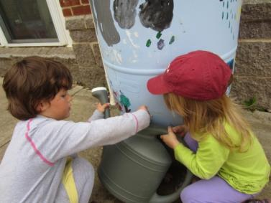 | 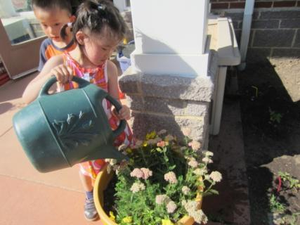

2-Schoolyard Habitat- Completed February 2014
The PTA will be asked to purchase the sign for this award. Curriculum addressed includes biology as the children learn about the birds and insects on their schoolyard. Food Sources- We provide seeds, suet and have two hummingbird feeders. The playground has a berry bush, flowers including asters, petunias, chrysanthemums, several butterfly bushes, milk weed and crepe myrtle. There are many trees and bushes. Water Sources- There are two birdbaths. Cover and Places to Raise Young- There are at least 5 nesting boxes painted by the children, 3 evergreen trees and many dense shrubs. There are milkweed, aster and violet plants for the caterpillars in many of the gardens. One of our gardens has native plants only.
Feb. 8, 2014- The PTA agreed to purchase the School Yard Habitat sign.
Curriculum- February 9, 2014 the teachers had a workshop on gardens including how to attract butterflies and insects to the garden with teaching plans and ideas. Bird count data sheets were set out by the windows in each classroom and children began to fill them out. CYC was registered for the Audubon Societies’ February Bird Count and data was entered on February 19, 2014. Children helped record the data on the playground. Significantly more birds are observed when the feeders are full. Teacher Janice Gonzalez takes charge of making sure feeders are replenished each week with the help of the children.
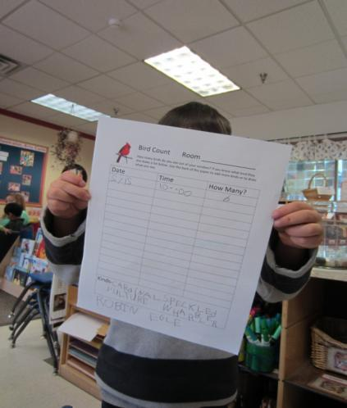 | 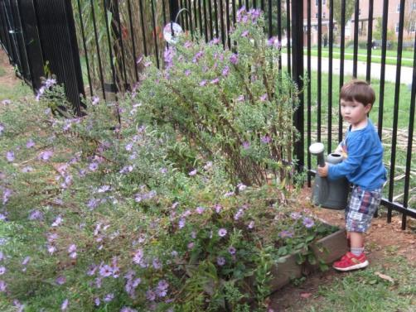
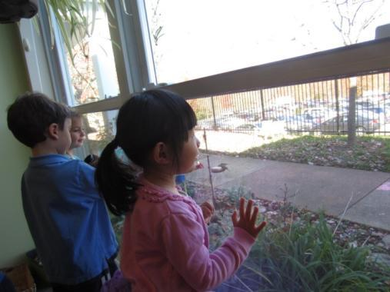 | 