Weekly Lesson Plan-Project Work
Study Topic: Sand and Rocks Classroom: Green Room
Date: April 9, 2012 Phase: Three Teachers: Mrs. Fowler and Mrs. Person
Discussion/Activity for Meeting Time  Group Discussion:  Let’s share pages from our informational book.  3 children will share the pages they created last week for the informational book. They will talk about what rock they chose and what information they included.  What do you know now about sand and rocks? Children will share what they have learned through our study of sand and rocks.  What will we see on our field trip? What will we do? Children will discuss what they think they will see and do on our field trip to the Smithsonian Natural History Museum. | Fieldwork/Investigation for Center Time  Field Trip to the Smithsonian:  Children will attend a field trip to the Smithsonian Natural History Museum in order to explore their Hall of Geology, Gems, and Minerals during a self-guided tour.  Informational Book:  To create the informational book, children will select a rock. Then they will photograph the rock, and type information on a computer into the book’s template.  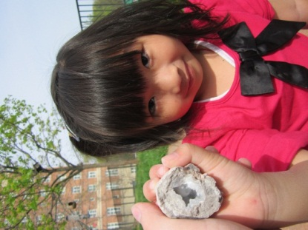  Yoyo showing her geode after cracking it open and finding crystals. | Representation/Display  Web:  Children’s ideas and predictions about the field trip will be written on a web.  List:  Children will list what they have learned about sand and rocks.  Informational Book:  Children will continue to create a class informational book about what they have learned about rocks.
Reminders: The CYC will be closed on Friday, April 13, 2012.
Literature for Story Time: This week we will read Bone Soup by Cambria Evans, Talk and Work It Out by Cheri Meiners, Do Unto Otters by Laurie Keller, and Time to Say Please by Mo Willems.
Visual Arts: We will have water color paints available for children to use.
Literacy: We will continue to have rock and mineral informational books available in the book area for children to explore independently.
Mathematical Thinking: We will continue to play games at the math table such as Snail Pace Race, and Hi Ho Cherry-o.
Social Studies: We will have a large pot and a stone available for use in the Dramatic Play Area.
Scientific Thinking: This week we will have a Block Area Challenge where children are encouraged to build using only 25 blocks.
Maryland State Voluntary Curriculum Standards website: http://mdk12.org/instruction/curriculum/index.html

