Energy Eco-Action Plans

Energy-

Action | Class to do it/  Time table/Cost | How to Monitor | Link to Curriculum | Community involvement
1-Using natural light | Both  March 2014  Free | Determine hours (1 hr. per week) | Classes could decide on a lights out lunch day. Maybe Trash free Tuesday, or other time. | Invite the school to do it via email.
2-Light switch signs  Unplug Vampire signs | Both  March 2014  Paper | Count them | Saving electricity, maybe a book would help. | The signs invite the community to help
3-Close blinds at the end of the day. May need to buy more curtains. | Both  September 2014  Cost of curtains | Count hours closed? | Helping hand could be responsible at the end of the day. A calendar could be checked off when done. | Same as above
4- Seal doors and windows better | Both  September 2014  Cost of weather stripping |  | Learning about energy loss in a building | Have a parent help

1-Using Natural Light
February 25, 2014, the Green Committee bumped up their Trash-Free Tuesday to include the use of natural light. Teachers are turning out the lights and promoting the Tuesday lunch as a “fancy lunch”. This saves an extra one hour of 108 32 watt bulbs being used. Some teacher’s have added table cloths and flowers to make the event even more enticing.
Curriculum- Children in each class are taught to sort trash by three types (compost, recycling, and landfill) at the beginning of the year. Each class comes up with three rules to use throughout the year one of which is to take care of their world. Using books for ideas, children come up with ideas that are recorded by the teachers.
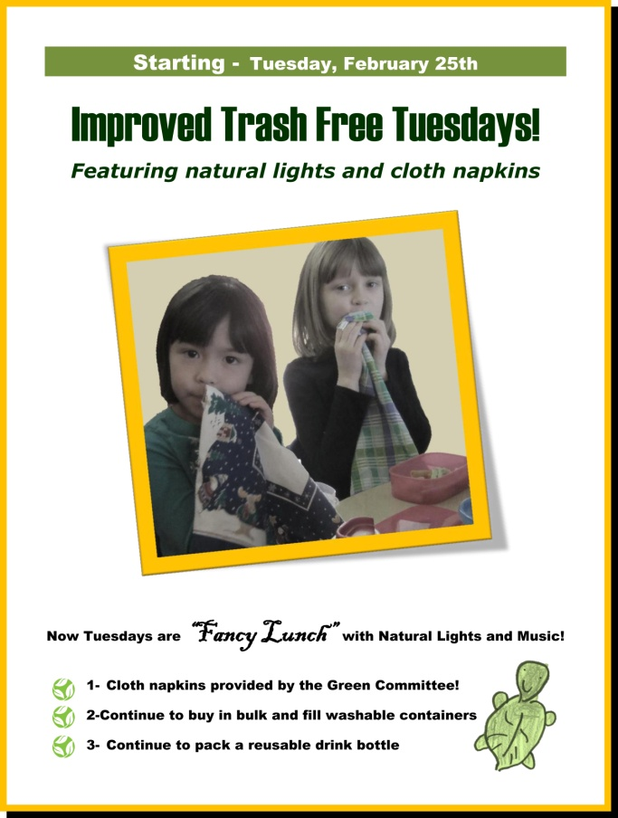 | 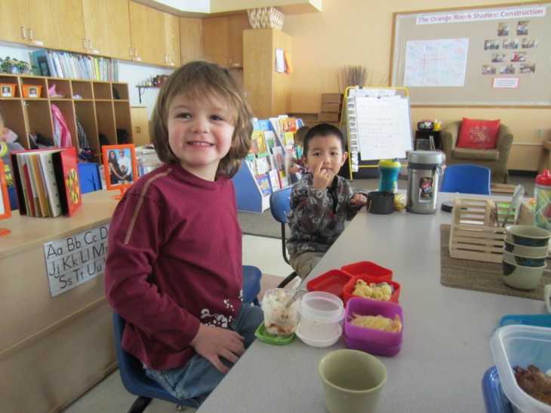

2-Turn off the lights and power vampire signage
February 12 – March 5 the Kindergarten Green Committee made signs to remind the CYC community to turn off lights and unplug energy vampires. The campaign was enhanced after a representative from Facilities, Mr. Vucci, came to talk to the children about energy. Posters and signs from the Sustainability department on campus were shown to the Kindergarteners to inspire them. Children decided where they would put each sign by touring around the school and looking for places that appeared to be problematic. Children planned to visit these sites again to see if things had improved. A total of 17 signs were made initially.
Curriculum- Children helped with the Eco-School energy audit by counting classroom lights and checking for air leaks around windows and doors as part of their science and math workshop. They recorded their findings on paper.
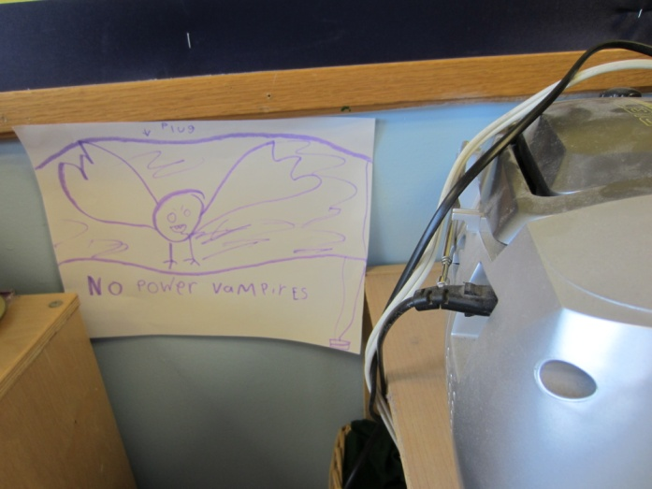 | 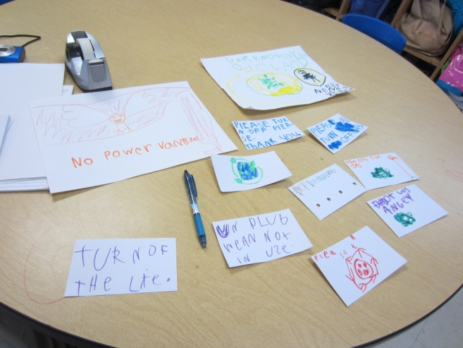
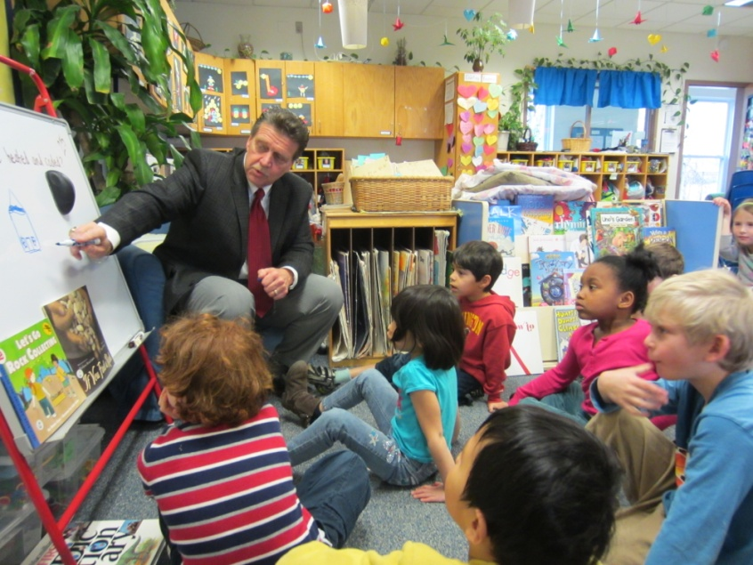 | 