sonKindergarten Lesson Plan
Topic: Electricity Teachers: Stefanie Kain & Alison Hurst Date: 2/13/12
Monday | Tuesday |  | Wednesday | Thursday |  | Friday
Math Workshop  Let’s do another story problem! How can we solve this problem? Hannah had 8 markers then Brandon gave her some more. Now Hannah has 14 markers. How many did Brandon give her?  Also, do you think Mrs. Kain’s baby will be a boy or a girl? During Math Workshop we will graph our predictions! | Reader’s Workshop  We will have new books as a choice for Reader’s Workshop. These books will be just right for you to read. Some books have 2 words on each page and others have many more. Let’s talk about how you know which books are best for you. |  | Writer’s Workshop  What was your favorite part of Toys Go Out? Special paper will be available during Writer’s Workshop to write about it. | Reader’s Workshop  Let’s read a big book entitled, Detective Dog. But someone has hidden some of the words! Let’s try to figure them out! |  | Writer’s Workshop  Two children will share in the Author’s Chair.
Project Meeting  Let’s talk about what we remember from Liam’s dad’s visit.  -electricity flows through a circuit  -a switch can cut off a circuit  -electricity can travel through air, water, wire, and ice | Project Meeting  IT’S THE 100TH DAY OF SCHOOL!!!  Can you think of 100 words?  During Center Time, we will have special 100th Day questions. |  | Project Meeting  Let’s discuss what it means to save electricity, why we need to save it, and how we can save it. | Project Meeting  Ms. Srun, a conservationist, will talk to us about saving electricity. |  | Project Meeting  What do you remember from Ms. Srun’s visit?
Language Arts:  Let’s read some books about the 100th Day of School and electricity.  Science:  Batteries, wires, and circuit boards that Liam’s dad showed us will be available to explore. The opened DVD player will also be available. |  | 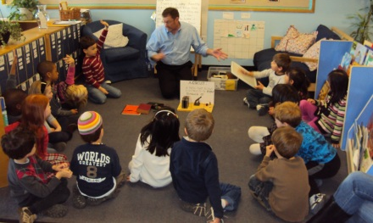  Liam’s dad talks to the class about electricity. |  |  | Math:  New puzzles will be available to explore.  Art:  Special acrylic paint will be available to create murals on lamination for our windows.
Announcements:
- Tuesday is the 100th Day of School AND Valentine’s Day!
- 100th Day homework is due no later than Tuesday
- There will be no reading homework this week.

