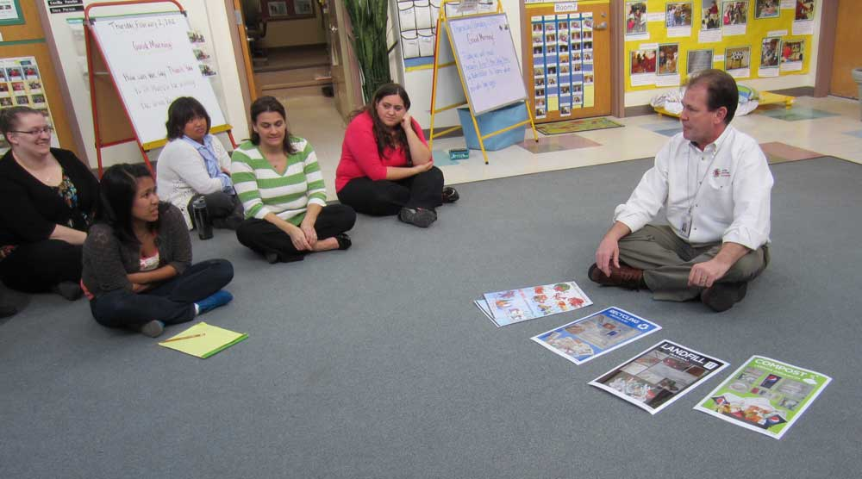
RE: Composting Talk

It would be my pleasure. my family is leaving out of Dulles at noon on Thursday I should be there by 2:00, is there a # in case I run into trouble.
Have an awesome weekend, kind of makes you believe in global warming with such beautiful temperatures.
gulp.
Greg
________________________________________
From: Vera Wiest
Sent: Friday, January 27, 2012 2:27 PM
To: Gregory K. Thompson
Cc: ffavrett@umc.edu
Subject: RE: Composting Talk
Hi Greg,
Thank you for looking.
What we really need is just for you to say you came and talked to the teachers, I guess that was the same week in November. I have pictures and lesson plans from when you talked to the children. They want us to have professional development documentation. If you could come to the CYC, say next Thursday around 2:00 to give the teacher's a short refresher we would greatly appreciate it.
Thank you so much, Vera
________________________________________
From: Gregory K. Thompson
Sent: Friday, January 27, 2012 1:46 PM
To: Vera Wiest
Cc: Francine Grace Favretto; Gregory K. Thompson
Subject: RE: Composting Talk
Hi guys, so far these are the only dates I can find, but I know there were more, just say the date and I will sware to it
Greg
Always at your service
________________________________
From: Allison Gail Lilly
Sent: Thursday, January 19, 2012 11:14 AM
To: Gregory K. Thompson
Subject: RE: OZZI Data
Hi there!
The only dates I saw on the posters/pictures were 3/16/11 and 11/16/09. Does this help? I looked through all the pictures.
Talk soon!
Allison
From: Gregory K. Thompson
Sent: Wednesday, January 25, 2012 4:29 PM
To: Vera Wiest
Cc: Francine Grace Favretto; Gregory K. Thompson (gkt@umd.edu)
Subject: RE: Composting Talk
You betcha, and I am so sorry I forgot to get back to you guys about the dates for the compost demonstrations needed, my email is acting up, and I cant search right now, but I did get some dates off of the wonderful full size drawings we have hung on our sustainable office wall, I will send those ASAP.
If we could stay away from Wednesday meetings that would be great any other day is good let me know when you would like me to come over, I can bring samples or marketing material? What would be best?
Let me know and it shall be done
Greg
At your service
From: Vera Wiest
Sent: Wednesday, January 25, 2012 9:15 AM
To: Gregory K. Thompson
Cc: Francine Grace Favretto
Subject: Composting Talk
Hi Greg,
I am teacher from the Center for Young Children. Back in the winter of 2010 you gave the teachers a quick lesson on composting and started us off on your great composting program.
Do you think you would be able to do a refresher course for us? A good time would be when the teachers are out of the classroom while the children nap between 2:00 and 3:00. We sincerely hope you can. Thank you too for agreeing to be part of our Green Committee.
Sincerely,
Vera Wiest
________________________________

