Kindergarten Lesson Plan
Topic: Trees Teachers: Alison Hurst Date: 4/9/12
Monday | Tuesday |  | Wednesday | Thursday |  | Friday
Math Workshop  Let’s learn a new math game. High-Low is a two person game using a deck of cards (face cards removed). Each person flips a card from their pile. Whoever has the higher number gets the cards. These rules are similar to the game War. | Reader’s Workshop  Th, Ch, Sh, Tr, are all sounds in our new game for Reader’s Workshop. Each player will role a dice which will land on one of the sound chunks. The player will then move their piece to the next picture with that sound in the word. |  | Writer’s Workshop  Let’s add ‘am’, ‘an’, ‘as’, and ‘are’ to the word wall. We will use white boards to practice writing them in meeting. | Reader’s Workshop  We will read Robin’s Room by Margaret Wise Brown. The front cover will be hidden, and after reading the story, students will decide what the title of the book should be. |  | Writer’s Workshop  NO  SCHOOL
Project Meeting  What do you know about trees? Let’s write all of our ideas on a web. | Project Meeting  What is an observational drawing? We will go outside to the playground and areas around the CYC to draw a tree that we see. |  | Project Meeting  We will share our observational drawings. | Project Meeting  We will share our observational drawings. |  | Project Meeting  NO  SCHOOL
Language Arts: We will continue to read Pippi Longstocking. We will practice recalling what happened in the previous section as well as predicting what will happen next.  Music: International music will be playing in the hallway. Musical instruments will be available for children to play along with the music. |  | 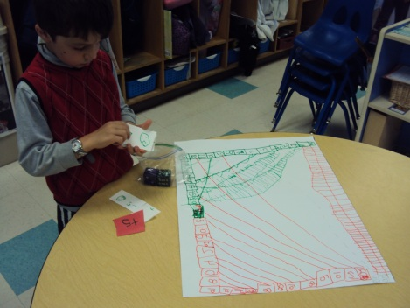  Andre made his own subtraction board game. |  |  | Math: Ms. Aung’s dice game will be available for continued exploration. Each student will role a dice and subtract that number from 10 and write the number sentence.  Sensory Table: A sand table will be available with various objects hidden. The children will need to use chopsticks to remove the objects from the sand table.
Announcements:
- Homework is due on Thursday
- Vision and Hearing tests will be on Thursday
- CYC is closed on Friday

